The Bi Man
- Importing Excel Data - Folder Path
  - Paste Folder path in Folder get Data tab and then click transform Data then right click on Content remove other columns the Add Custom Column M code [Excel.Workbook([Content]) then we would keep Custom Column and remove Content Column Remove Other column till you finally see the Required Data Frame
  - Then instead of headers we will see Column1, Column2, ………., ColumnN -- Then use First Rows as Headers
  - When we Paste Next Months Data the Headers appear again So we Click on anyone Column and unfilter the Name of Headers from values and we are good to go
  - If we Don’t want to so the above a, b & c steps then there is a better way of doing it Excel.Workbook([Content]) we Need to add True over here so we don’t need to deal with Headers in next files what Ture does here is detect the Headers
Excel.Workbook([Content],true) if we have a CSV file then Csv.Document([Content],true)

- L-01: Getting Started with PBI
  - Which Power Bi version are you using – May 2026 (Interview Q)

- L-02: Power Query
  - Where have you taken the data from, I mean from Which folder and what if the File location changes then how to solve this in PBI in Applied Steps go to Source And Paste the New path (Interview Q)
  - Applied steps are same as macros in Excel file and the same steps gets applied to the next file or data that is appended or inserted
  - In the Power Query Editor we can only see 999+ rows. The data has more rows how to find out that We can click on column profiling based on Entire Data set - this is used for column profiling I guess (Interview Q)
  - What is Data Profiling for this we go in View Tab then select Column Distribution, Column profile, Column quality (Interview Q)
  - Data Profiling : Also Data profiling is the process by which we get to know the Quality of data is ther any empty spaces, is there any error in any column, how much % of valid data is present in column, statistics of the data (Interview Q)
  - What is the meaning of Null means Nothing (Interview Q) Also Null =! Null
  - Try to keep ZipCode, ID, Barcode DataType as “Text” because we are not going to perform any aggregate functions on this & keeping in text makes it searchable In these case text is more efficient than number.

- L-03: Date & Time Functions ***** (IMP) – Practice Date & Time
  - Transform Vs Add Column: If we see in Power Query Date & Time Functions Section, Number Section & Text Section are present in both then what is the difference between them
  - Transform: Whatever changes we are making using this it gets applied to the same Original/Existing column
  - Add Columns: This creates a new column for whatever changes we are doing on the given column

- L-04: Duplicate Vs Reference
  - Duplicate: When we Duplicate a Table it becomes independent of the Original Data/Table
  - Reference: When we Reference a Table, then whatever changes are being made to the original data/table all that changes are even reflected in Reference Table also It is dependent on Main Table here a Parent & Child Relationship is there
  - Note: But Whatever Changes we do in Reference Table that is not executed in the Main parent table
Shortcut Keys: If we want to see the name of all columns in Power Query in Table view then Ctrl+G
- L-05: Marge Vs Append, ALL Joins

- L-06: Pivot Vs Unpivot
  - Unpivot: Converting columns into rows is known as Unpivot
  - Pivot: Converting rows into columns is known as Pivot

- L-07: Group By
  - Grouping By Department & City For City Name select Operation as All rows
  - Then Change the M Code to view All cities in One Line for a Single Department
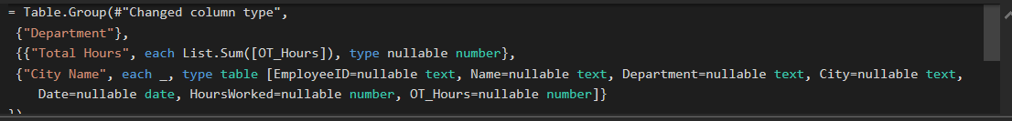
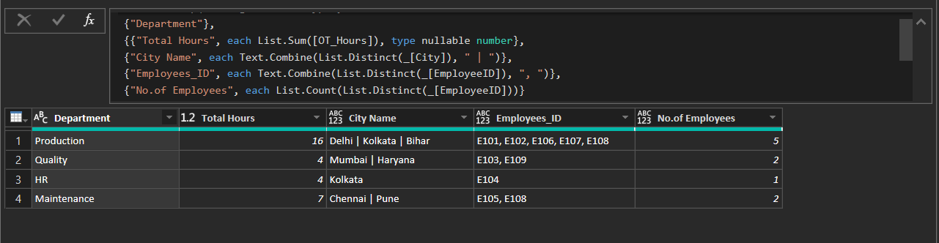

- L-08: Power Query: Here we have 3 Tables Production, Forecast, Employee Table
  - What is the Difference between Pivot, Unpivot & Transpose
  - Trasnpose: Interchanging Rows to Column and columns to rows
  - Unpivot: Converting columns into rows is known as Unpivot
  - Pivot: Converting rows into columns is known as Pivot
  - Text.Pad use in Data Cleaning?
- L-09 Data Modelling: Organizing & structuring our data into logical tables and defining relationship between them
  - Primary key: Each row represents one business entity, no duplicates, must be unique One side of relationship
  - Foreign Key: References the primary key in the dimension table, can contain duplicates, many sides of relationship
Rule of thumb: In Power BI, Dimension tables contain unique Primary Keys, while Fact tables store Foreign Keys that repeat many times to record transactions or events.
  - Dimension table has Primary key
  - Fact Table has foreign key
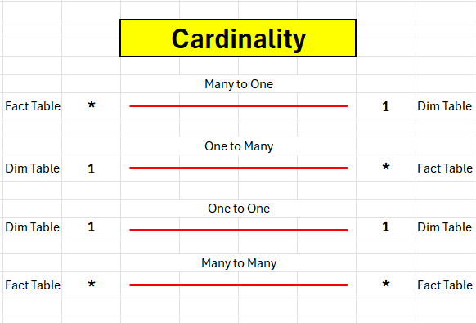
  - Data propagates from Dimensions to Fact Table
  - Mostly there will be no relationship between Dimension to Dimension Table
  - There can be only 1 Active relationship between Any two tables but if you want to have 2 relationships then it is possible by Use Relationship DAX
  - Calendar table is known as Role Playing Dimension As we sue it from Time Intelligence functions
  - What is the Direction of flow between Dimension & fact Table the flow is always from Dimension to Fact table

